Country-Specific Fact Sheet: Haiti

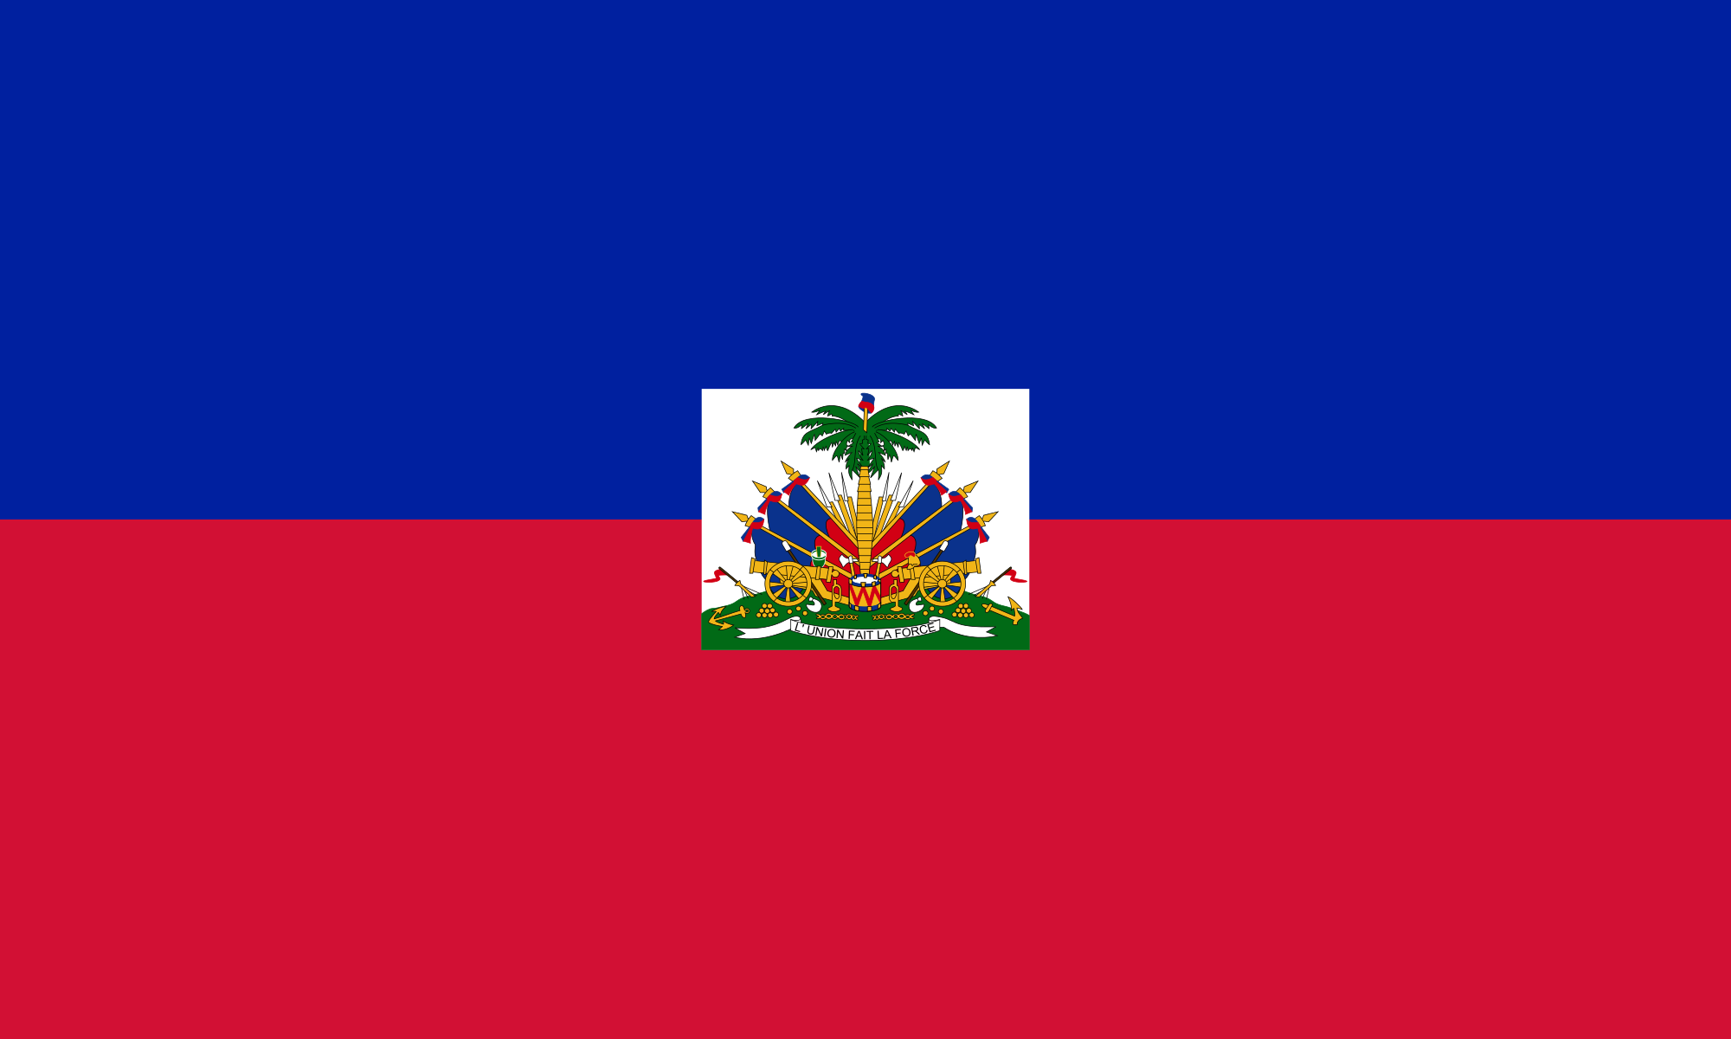
Travel Quick Facts:

Passport Validity: Must be valid at time of entry

Blank Passport Pages: 1 page required for entry stamp

Travel Visa: available for purchase at the Port-au-Prince airport, costs 10 USD (exact change)

Time Zone: 5 Hours ahead of Greenwich Mean Time

Currency: Haitian Gourde; 1 USD= 65 HTG

Voltage Requirements: 110 volts, Universal adaptor needed for non-US appliances

Calling Instructions:

To call a cell number from the USA: Dial 011 (USA exit code) +509 (Haiti Country Code) and then number.

To call United States from Haiti: Dial +1 + (area code) + phone number

Emergencies and Police: Dial 114
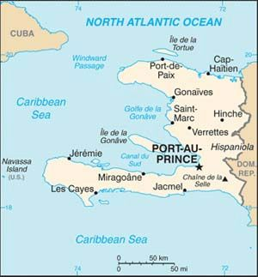
U.S. Embassy Port-au-Prince: +(509) 2229-8000
Emergency After-Hours: +(509) 2229-8122
Tabarre 41, Route de Tabarre, Port-au-Prince, Haiti

Health Concerns:
Dengue fever, Zika, malaria, chikungunya, diarrheal disease, cholera, typhoid, rabies

Vaccines:
Hepatitis A and typhoid are required vaccines in addition to all routinely recommended immunizations in the US. Measles, mumps, rubella, tetanus, pertussis, and chickenpox are much more common than in the US. Depending on where you are traveling within Haiti and what you will be doing, consider Rabies and Hepatitis B vaccines. For more information, please go to: http://wwwnc.cdc.gov/travel/destinations/traveler/none/haiti.

Cultural Facts:

Capital: Port-au-Prince

Government: Republic: Republic of Haiti

Population: 10,485,800

Language: Haitian Creole, French

Religion: Catholic- 54.7%, Protestant-28.5%, Other or none: 16.9. Voodoo is recognized as an official religion in Haiti; it is often practiced in addition to Catholicism or Protestantism.

GHESKIO:

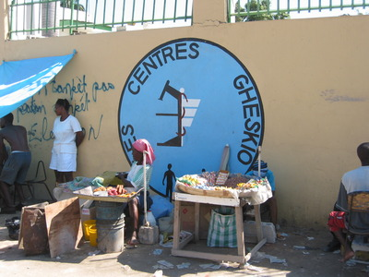
Location: Port-au-Prince, Haiti

Telephone: (509) 222-0031

Airport Information: Toussaint Louverture International Airport is about 45 minutes from GHESKIO. There are numerous flights per day to New York City, Atlanta and Miami. There are typically long lines so arrive at least 2 hours prior to any flight.

Taxi Information:
Often unavailable but if you are staying at a hotel, hotel staff can call a taxi for you. Prices vary widely depending on driver. It is best to take a taxi recommended by a colleague or hotel rather than ride with an unknown driver.

Suggestions for Professional Dress:
Men: long pants, dress shirts, closed-toed shoes. Ties are optional.
Women: knee-length skirts or dresses or dressy trousers. Avoid sleeveless tops. Avoid revealing clothing. Open-toed shoes (but not flip-flops) are acceptable.

Customs: Taking time to greet people and exchange pleasantries is important. Haitians usually greet each other with a kiss on the cheek (for women) or handshake (for men). Many Haitians speak some English but learning basic greetings in either Creole or French is encouraged.

Safety Tips: Haiti is a resource-limited country. In general, non-Haitians are considered wealthy. Always be aware of your surroundings. Keep expensive jewelry or electronics (such as smartphones) out of sight. Walking alone or at night is discouraged.

Tips for Connecting to the Internet:
Haiti has two main cellular networks, Natcom and Digicel. It is possible to purchase internet and phone plans from either of these companies. Additionally, if you have a US-based phone plan, it is possible to get international calling and data usage.

